**CS595 _HW2_CapstoneCourse_GroupAssignment**

**Team Members:**

Pratyusha Dommata (11091)

Shruti Rajan (10904)

Uttam Polkampally (12211)

Xianghui Ma (9957)

Sravani Anumula (12433)

**Q1. Set up JIRA for Agile software development process**

url:

<http://npu85.npu.edu/~henry/npu/classes/agile/jira/slide/exercise_jira.html>



JIRA is a [proprietary](http://en.wikipedia.org/wiki/Proprietary_software) [issue-tracking](http://en.wikipedia.org/wiki/Issue_tracking_system) product, developed by [Atlassian](http://en.wikipedia.org/wiki/Atlassian). It provides [bug tracking](http://en.wikipedia.org/wiki/Bug_tracking_system), issue tracking, and [project management](http://en.wikipedia.org/wiki/Project_management) functions.

Please click on the link below and select free trial

<https://www.atlassian.com/software/jira>



Choose Issue tracking and agile project management free trial for development

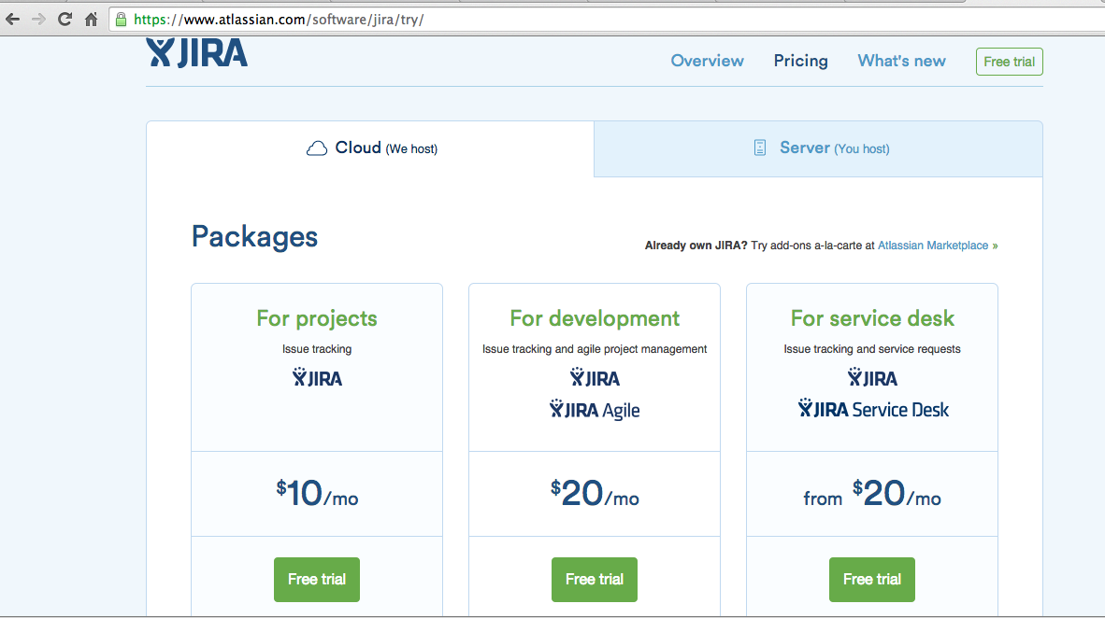

Click Next

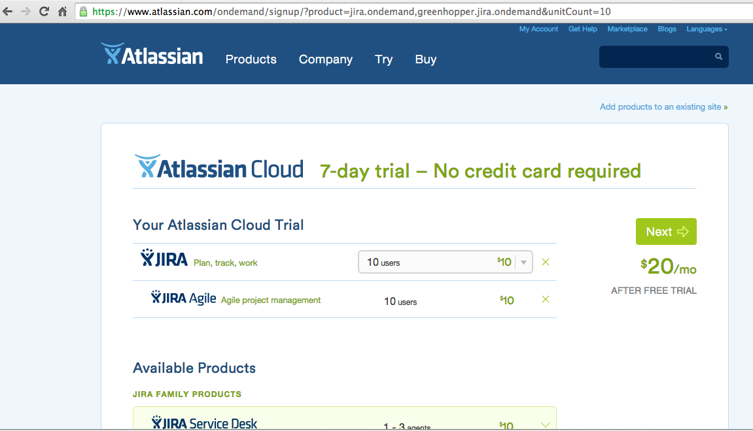

Note:

I have created a new Gmail account for our project purpose.

Email Id: [fallarmspring2015@gmail.com](mailto:fallarmspring2015@gmail.com)

Password: 2015springfallarm

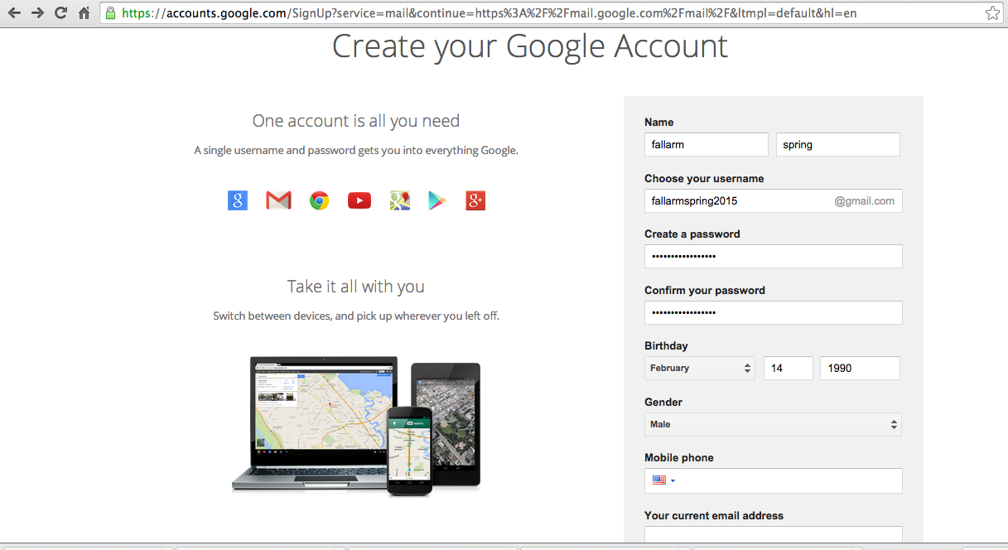

Fill in all below details and click on I agree and start your free trial

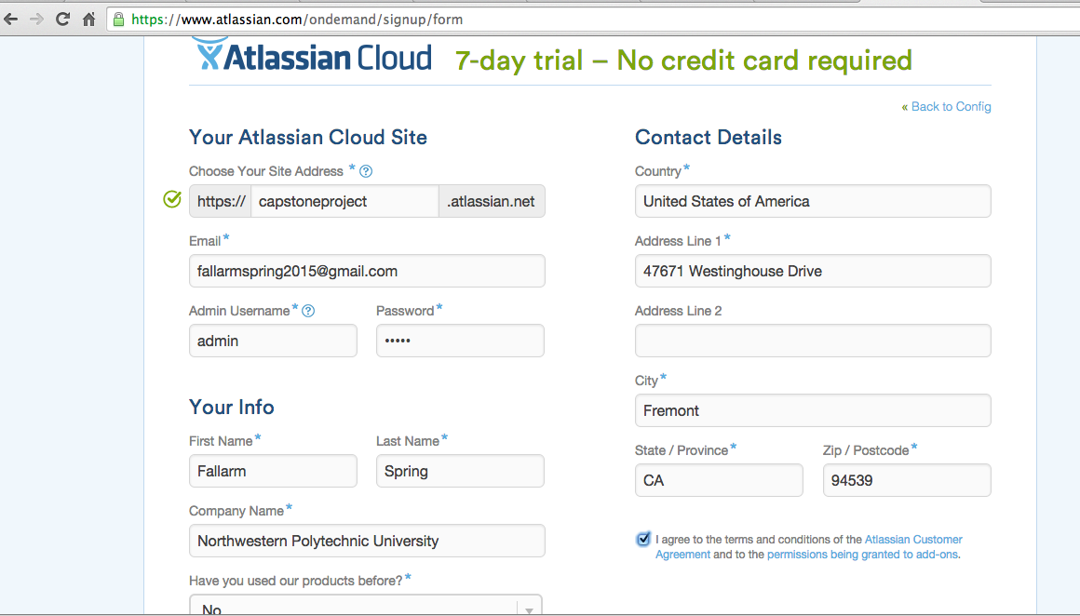

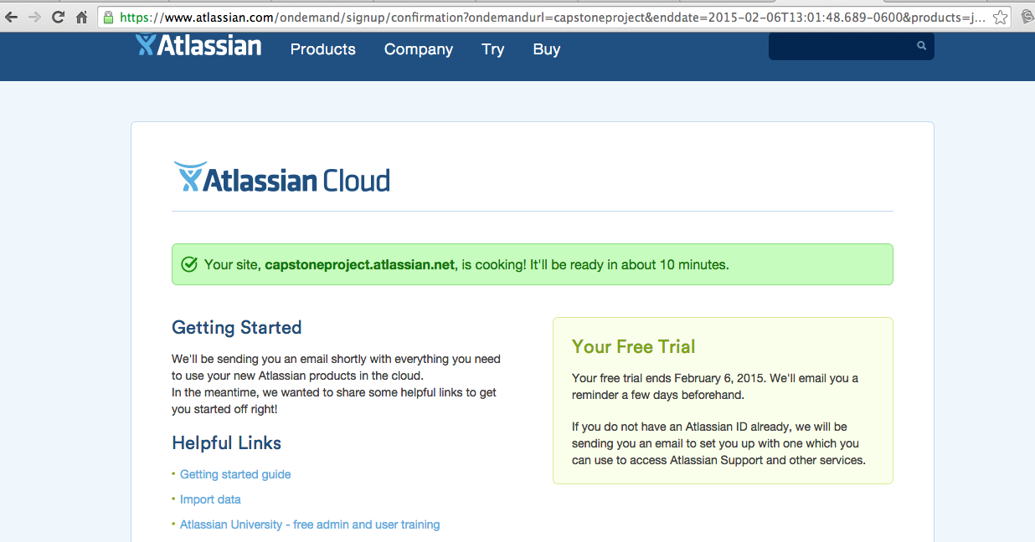

After 10 minutes, sign in to our capstoneproject.atlassian.net site as shown below:

Username: admin

Password: admin

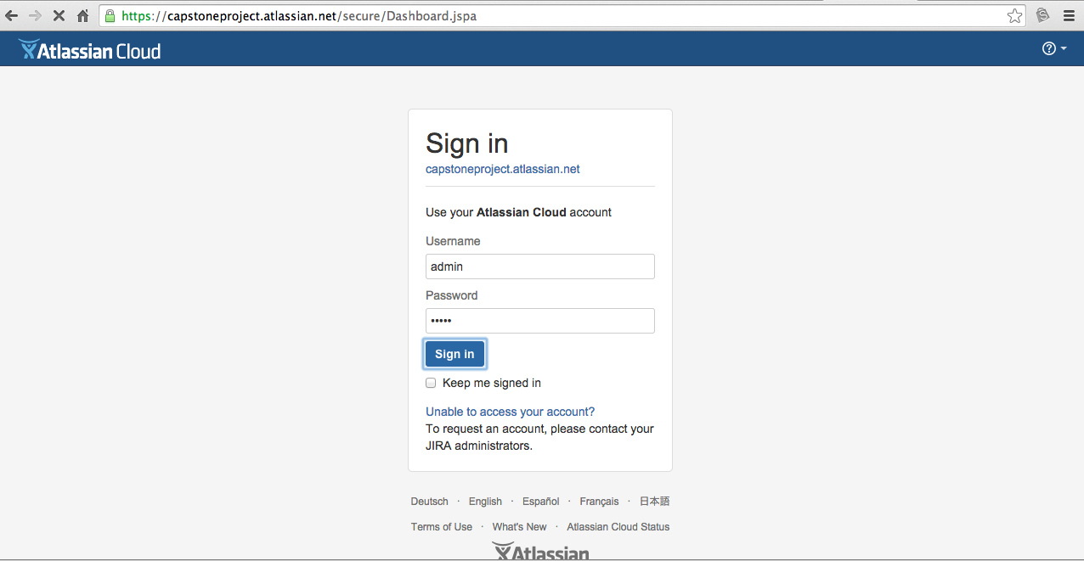

Below is the webpage that shows up once we sign in where we can create or import projects, invite members, etc

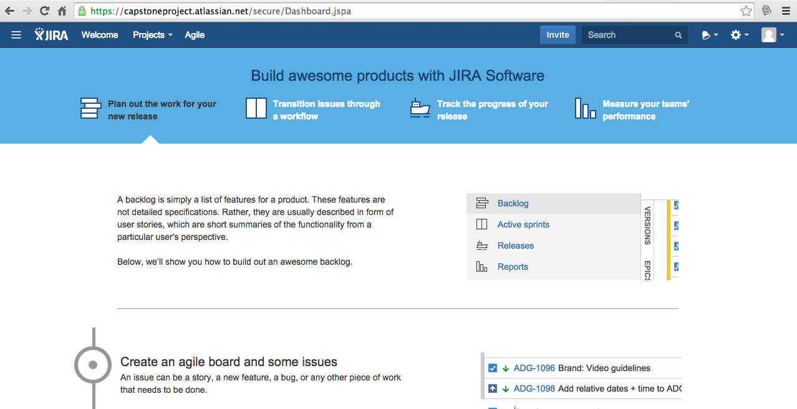

**Q2. Github**

url:

<http://npu85.npu.edu/~henry/npu/classes/capstone/qiris/slide/Getting_Started_with_GIT.pdf>



GitHub is a web-based [Git](http://en.wikipedia.org/wiki/Git_(software)) repository hosting service, which offers all of the [distributed revision control](http://en.wikipedia.org/wiki/Distributed_revision_control) and [source code management](http://en.wikipedia.org/wiki/Source_code_management) (SCM) functionality of Git as well as adding its own features. Git is strictly a [command-line](http://en.wikipedia.org/wiki/Command-line) tool whereas GitHub provides a [web-based graphical interface](http://en.wikipedia.org/wiki/Web_application).

In simple words, Git and Github is for developers / programmers to share their code online on remote repository. In a team, there will be many programmers working on a single project and using Github it will be easy to understand who changed what part of the code and also if something goes wrong, they can retrieve previous version of the code using Github.

There are 3 important Steps:

1. Sign up with Github (It’s Free..!)

2. Install Git on your system

3. Move code from your system to Github.com and vice versa



**Step1: Sign up with github**

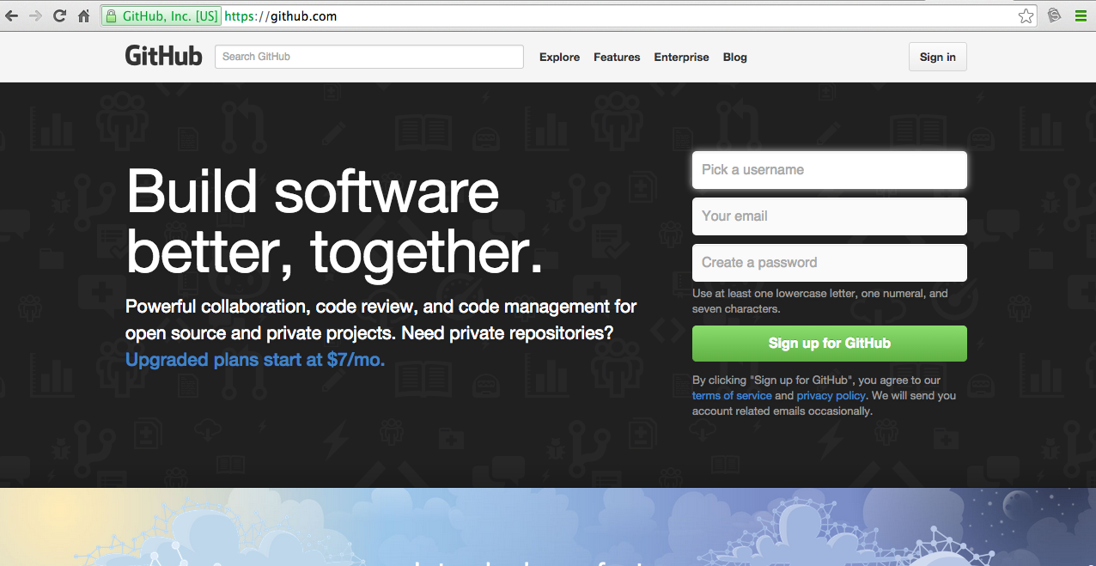

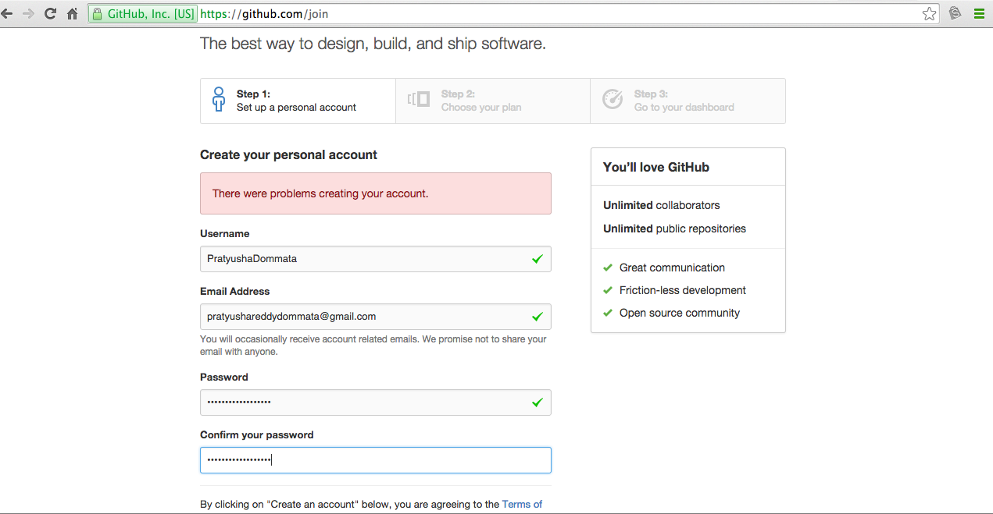

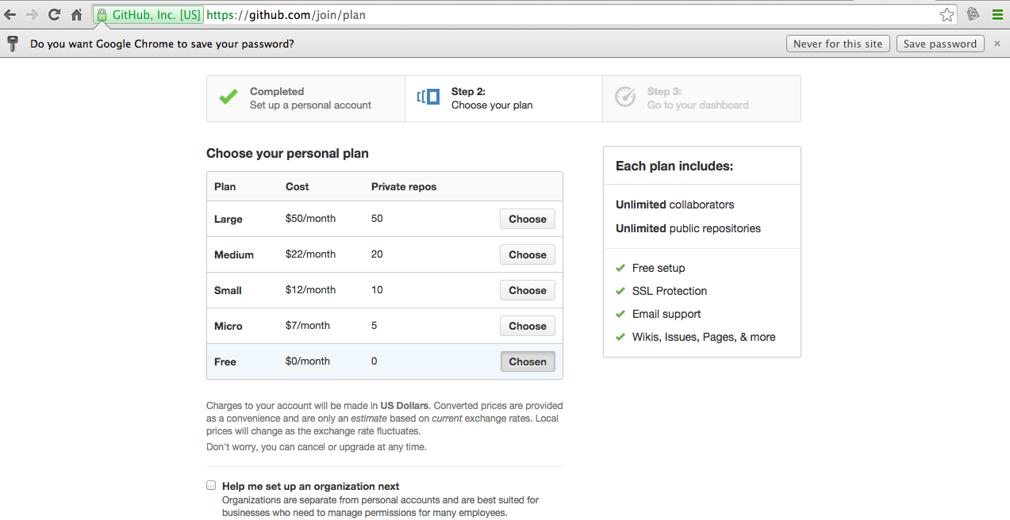

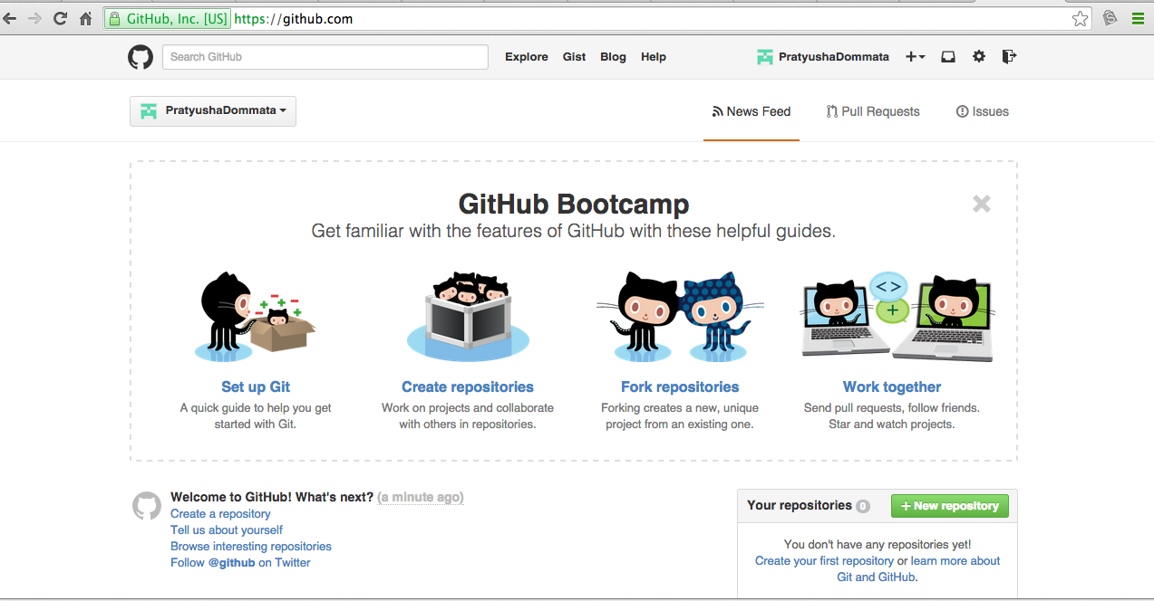

**Step2: Installation**

Please click on below link to Download and install Git for your system.

<http://git-scm.com/download>

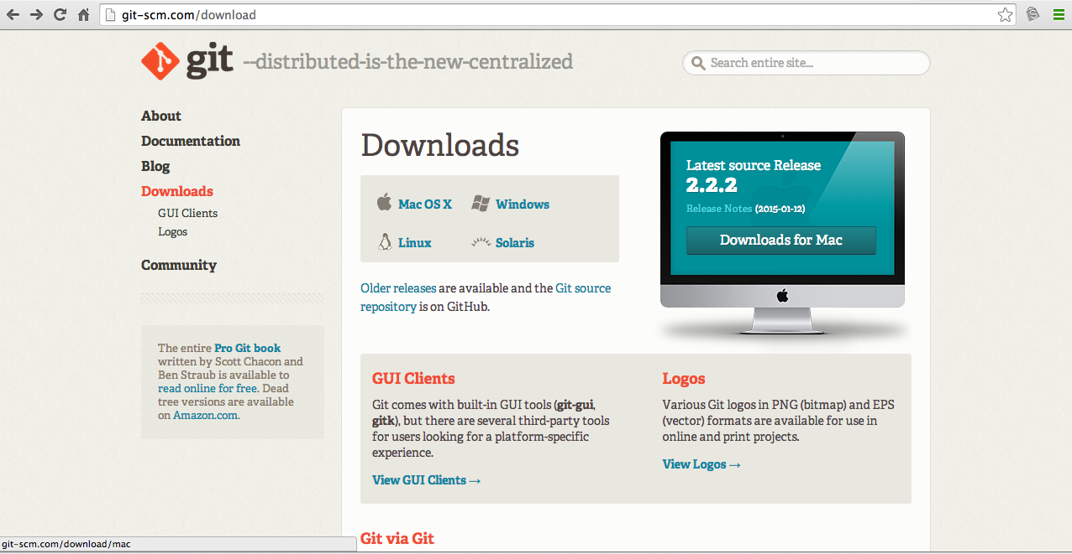

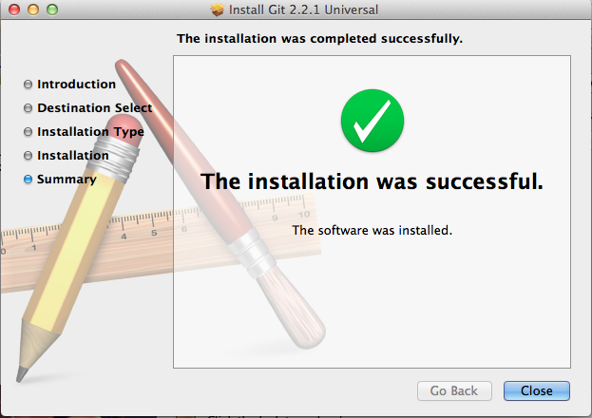

After installation, type git in your commandline, it should display list of git commands as shown in below screenshot. This verifies that we have installed Git correctly in our system.

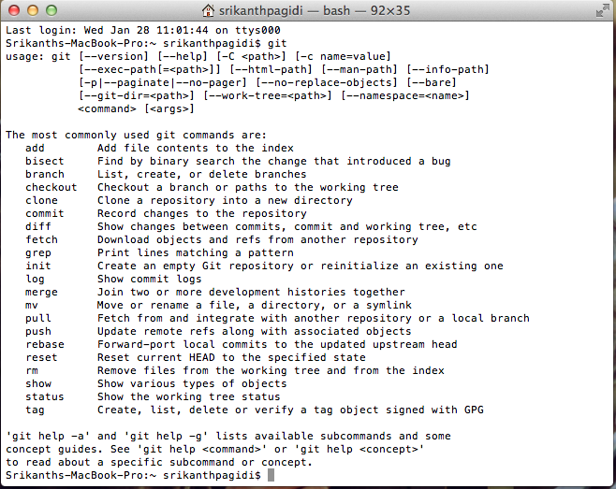

**Step3: Adding an existing project to GitHub using the command line**

1. [Create a new repository](https://help.github.com/articles/creating-a-new-repository) on GitHub. To avoid errors, do not initialize the new repository with *README*, license, or gitignore files. You can add these files after your project has been pushed to GitHub.

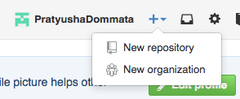

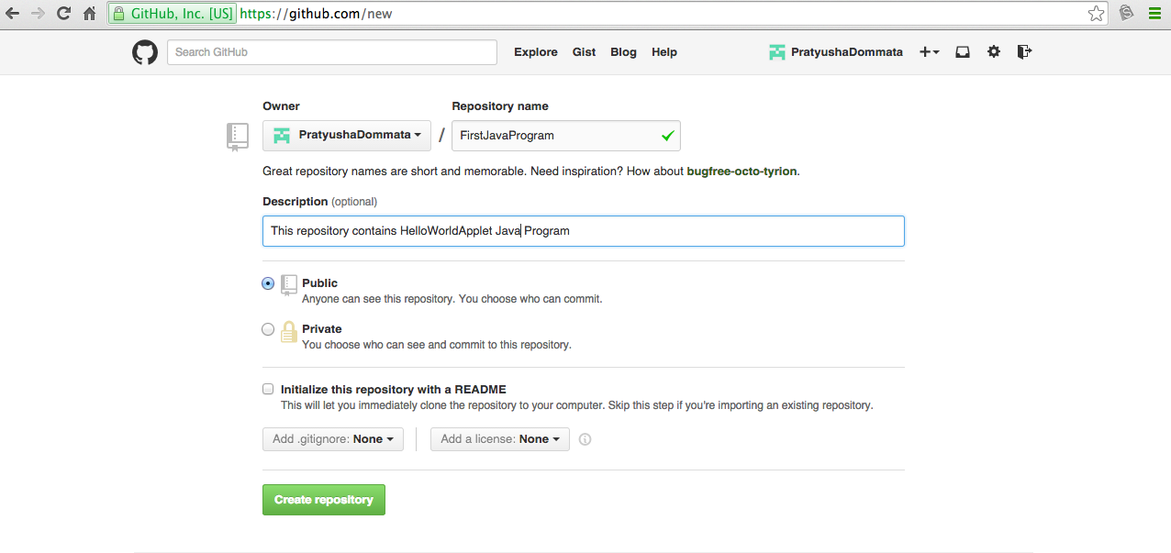

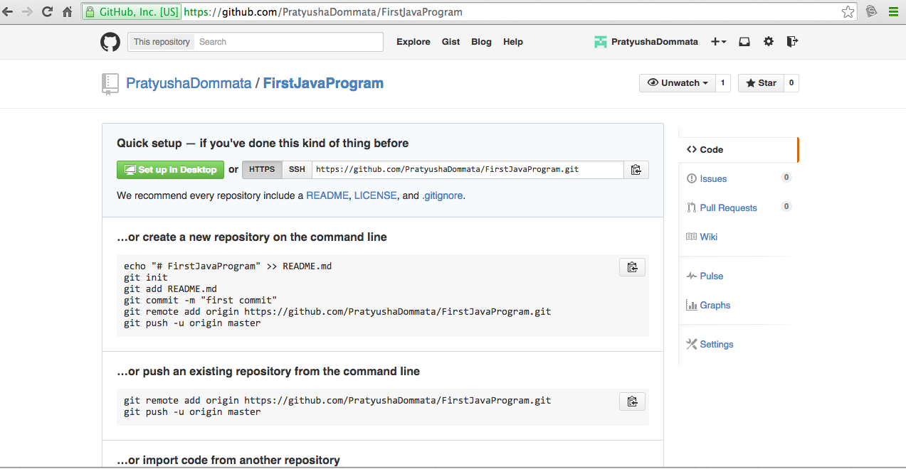

2. In Terminal, change the current working directory to your local project.

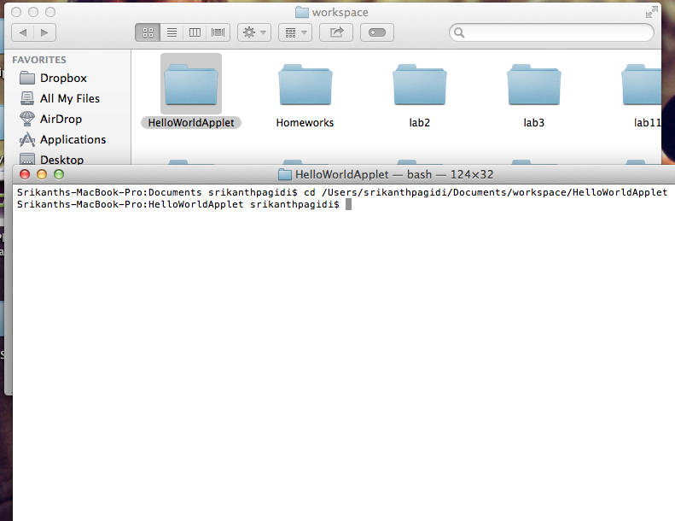

3. Initialize the local directory as a Git repository.



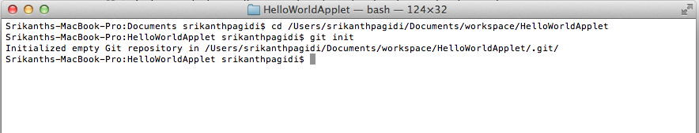

4. Add the files in your new local repository. This stages them for the first commit.



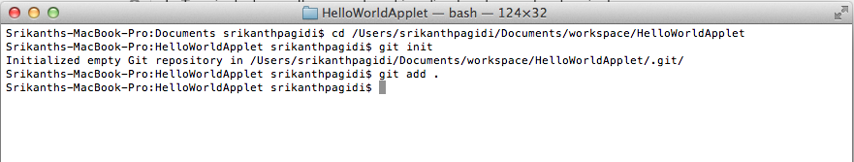

5. Commit the files that you've staged in your local repository.



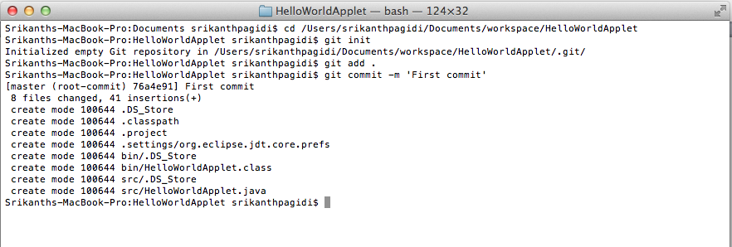

6. At the top of your GitHub repository's Quick Setup page, click  to copy the remote repository URL.



7. In Terminal, [add the URL for the remote repository](https://help.github.com/articles/adding-a-remote) where your local repostory will be pushed.

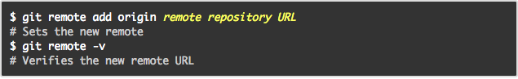

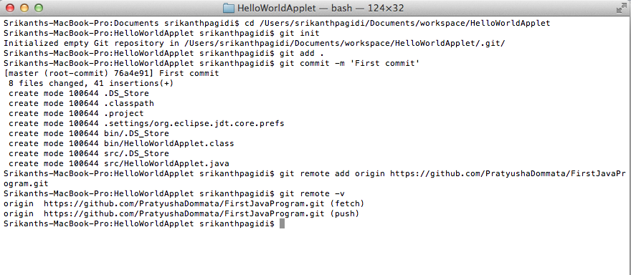

8. [Push the changes](https://help.github.com/articles/pushing-to-a-remote) in your local repository to GitHub.

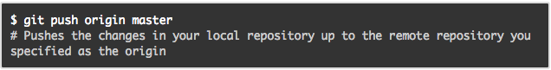

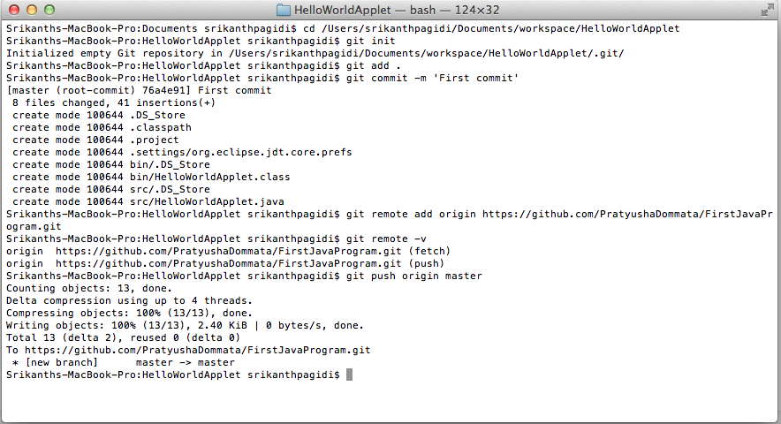

Refresh your Github.com to see your project as shown below:

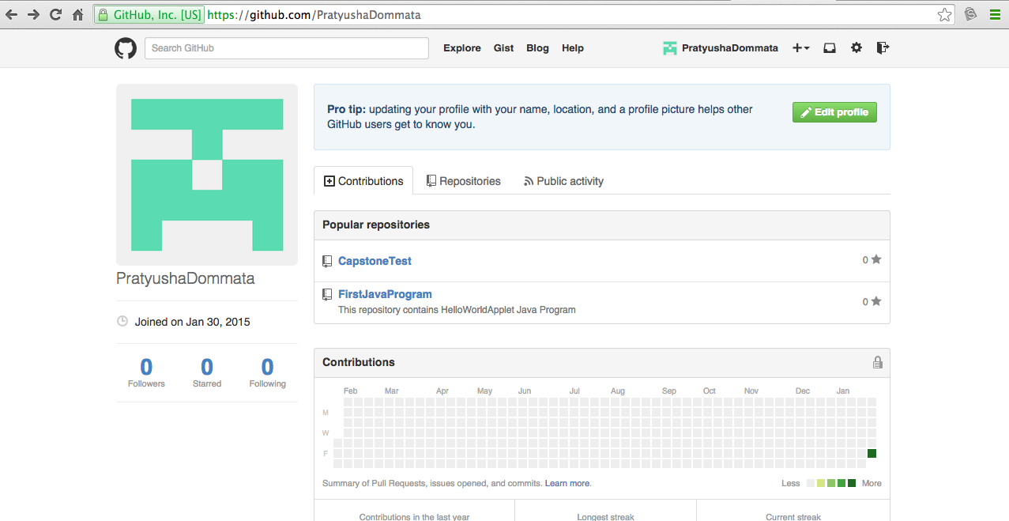

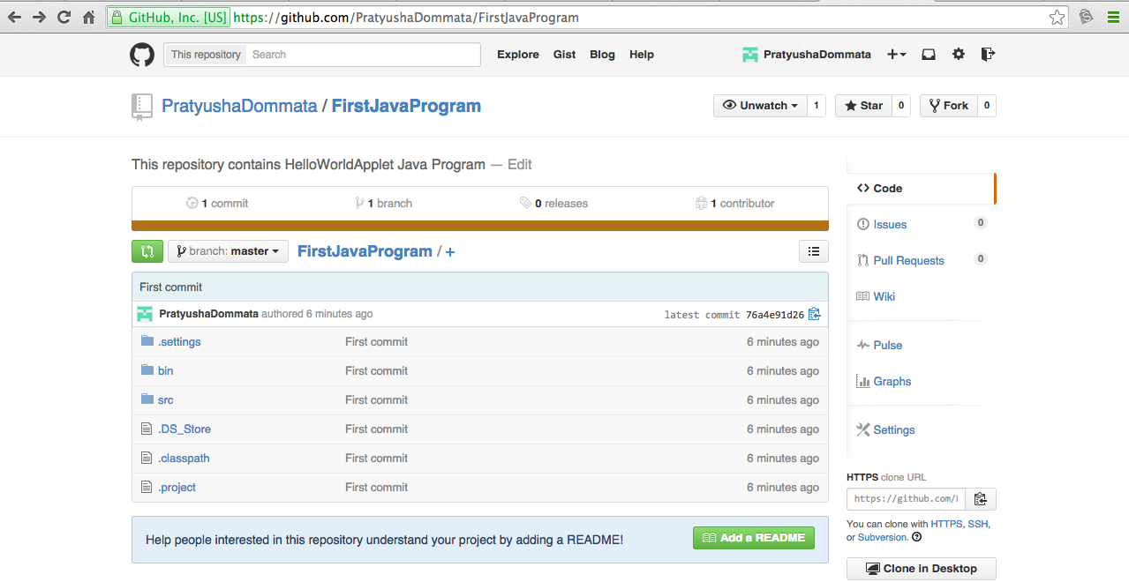

**Cloning repository and then adding a File to repository process:**

Click on New repository as shown below

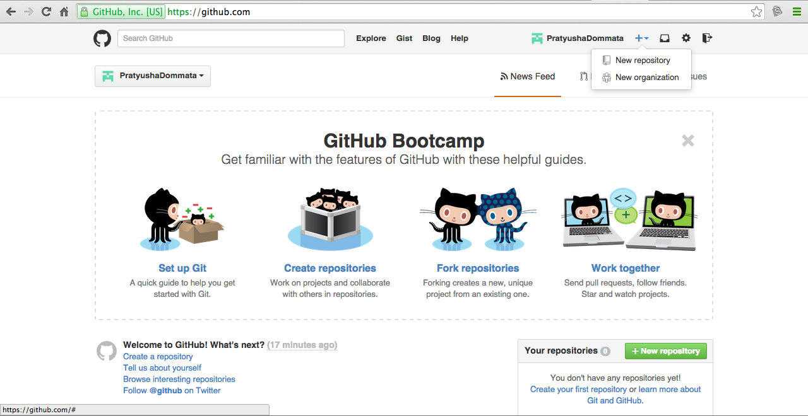

Enter repository name and also check initialize repository with README option so that we can clone the repository to our computer.

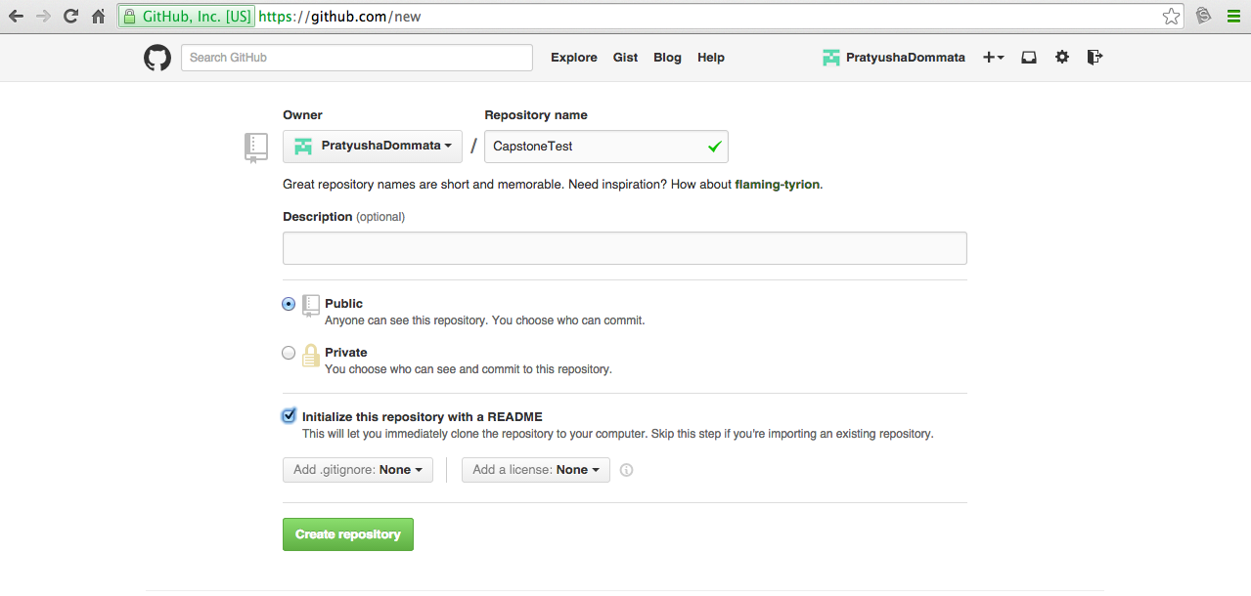

Once we click on Create repository, below webpage shows up

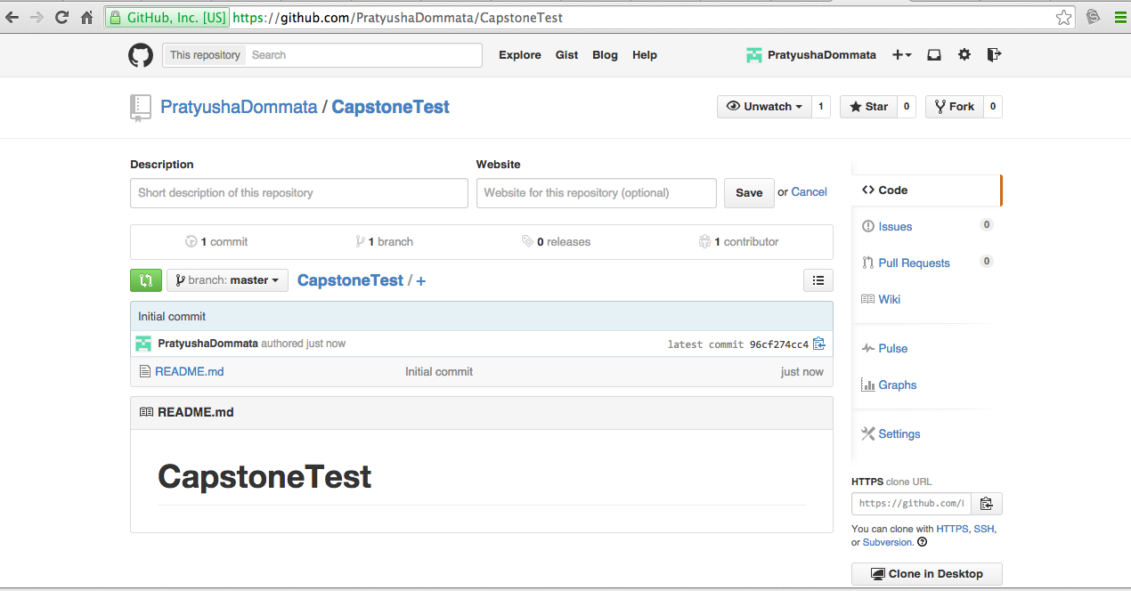

Copy this url

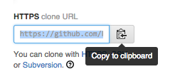

**Clone** your repository on Github to your computer using below commands

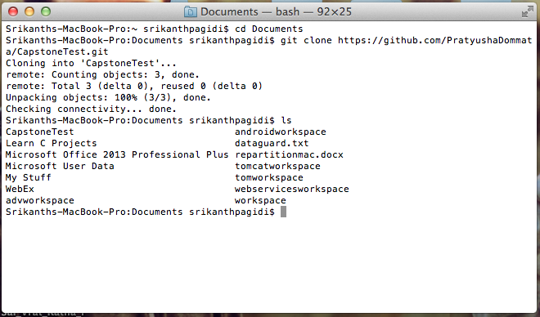

Now let us make some changes (for example: adding a .html file) to our repository, CapstoneTest.

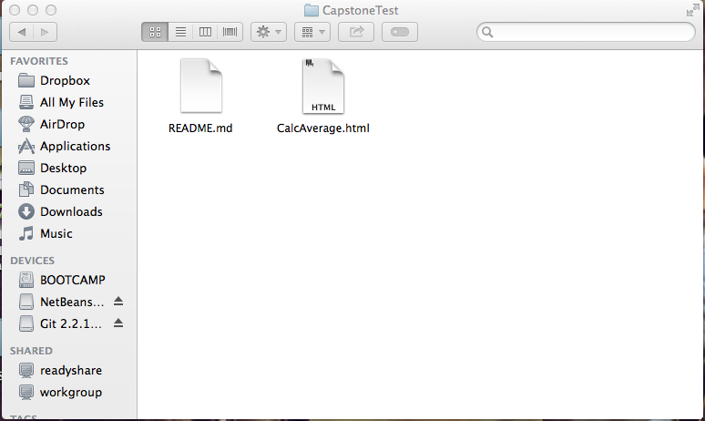

Once you are done making changes to your repository, check the **status** of your repository as shown below:

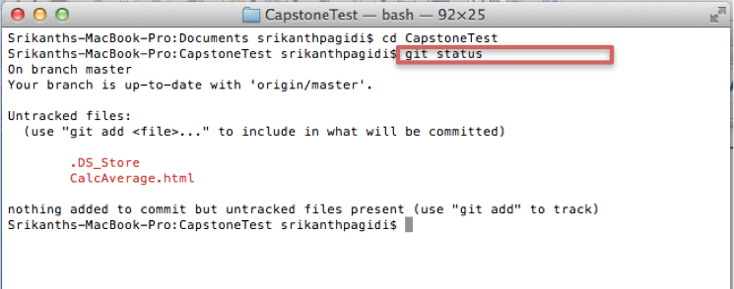

Once we have done some changes, we need to **add** and then **commit** to save changes to our computer.

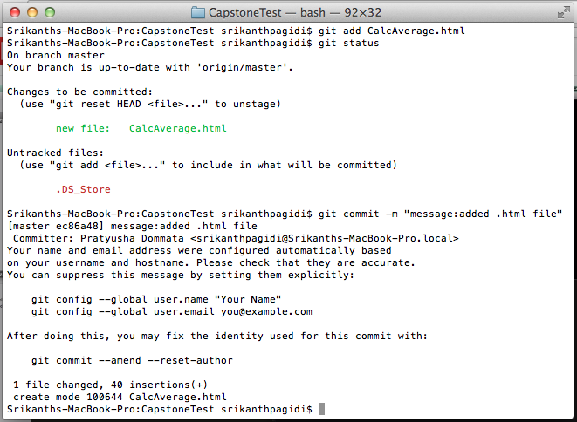

To push all these changes on to Github.com, use push command as shown below:

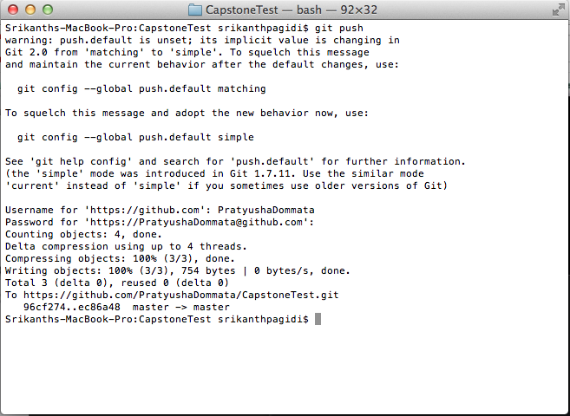

Go to your Github.com and refresh to see your newly added file as shown below:

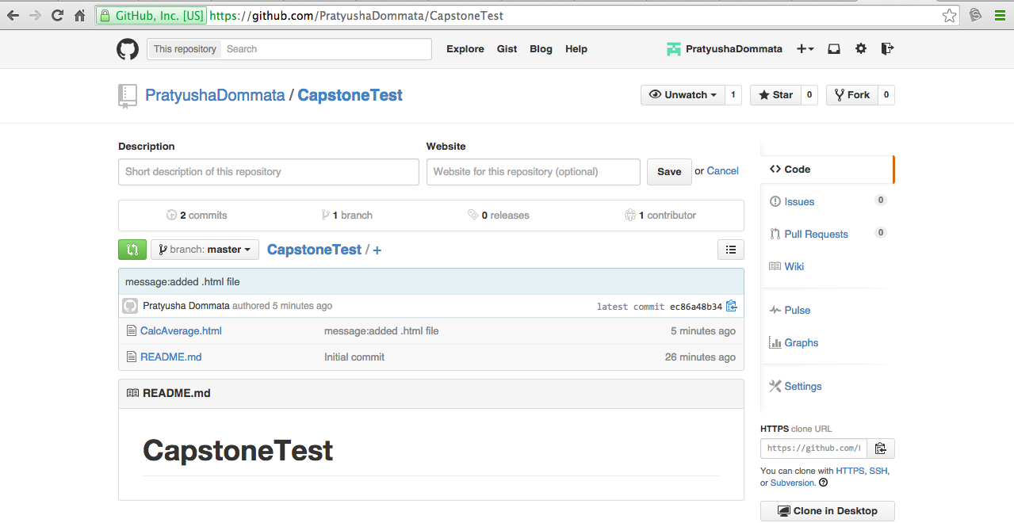

Note:

You can set these configurations if you want to so that we can keep a track of who did what on a project.



**Github for Windows:**

**Sign Up for GitHub**

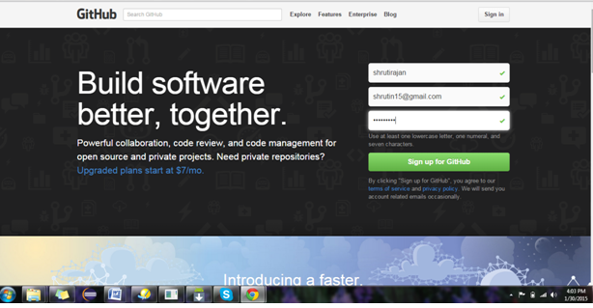

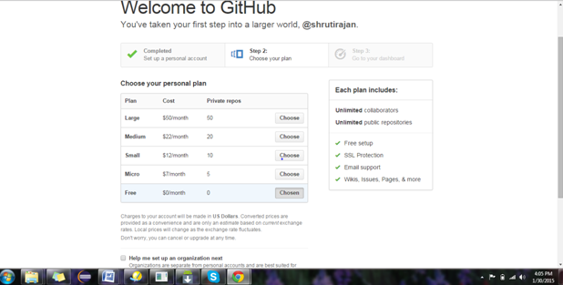

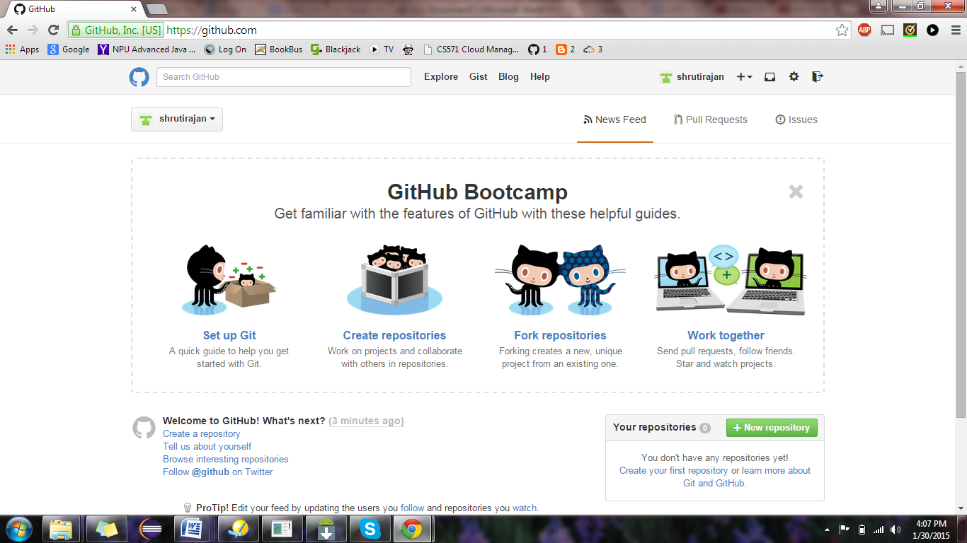

**Download Git hub for windows from the link: git-scm.com/download**

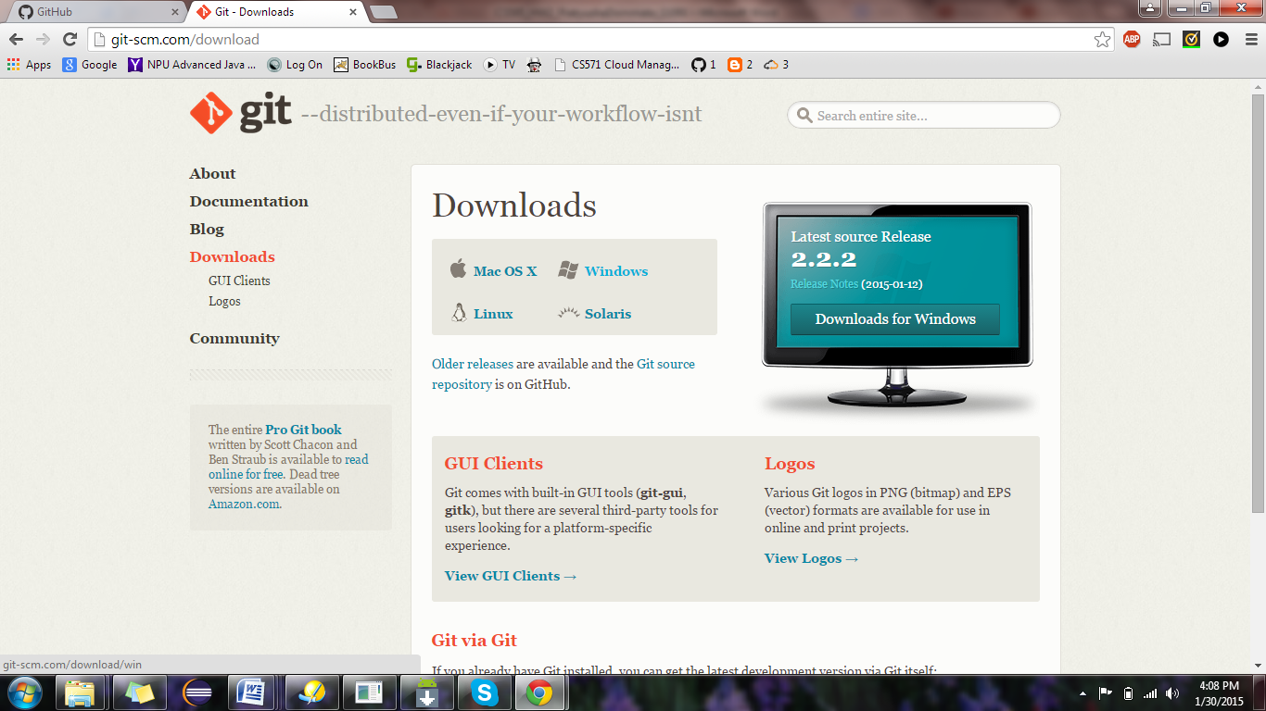

**Installation of GitHub**

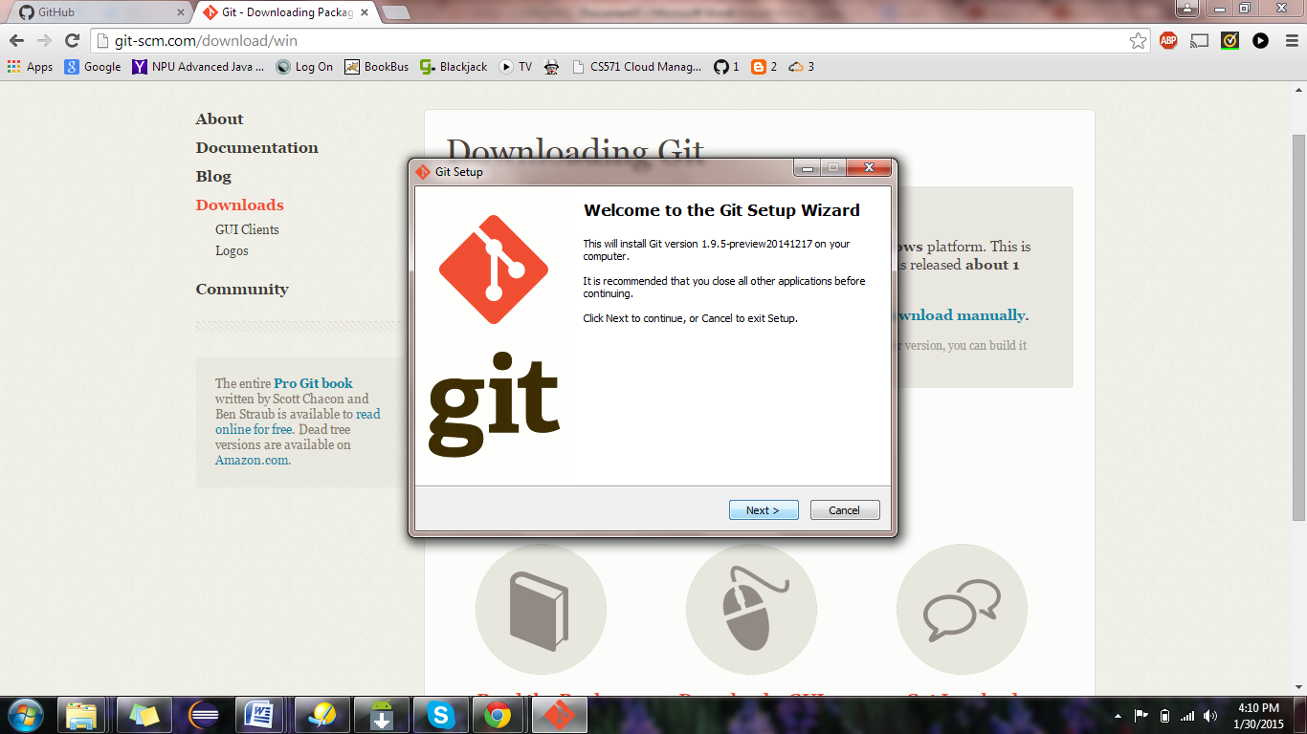

**Create New Repository**

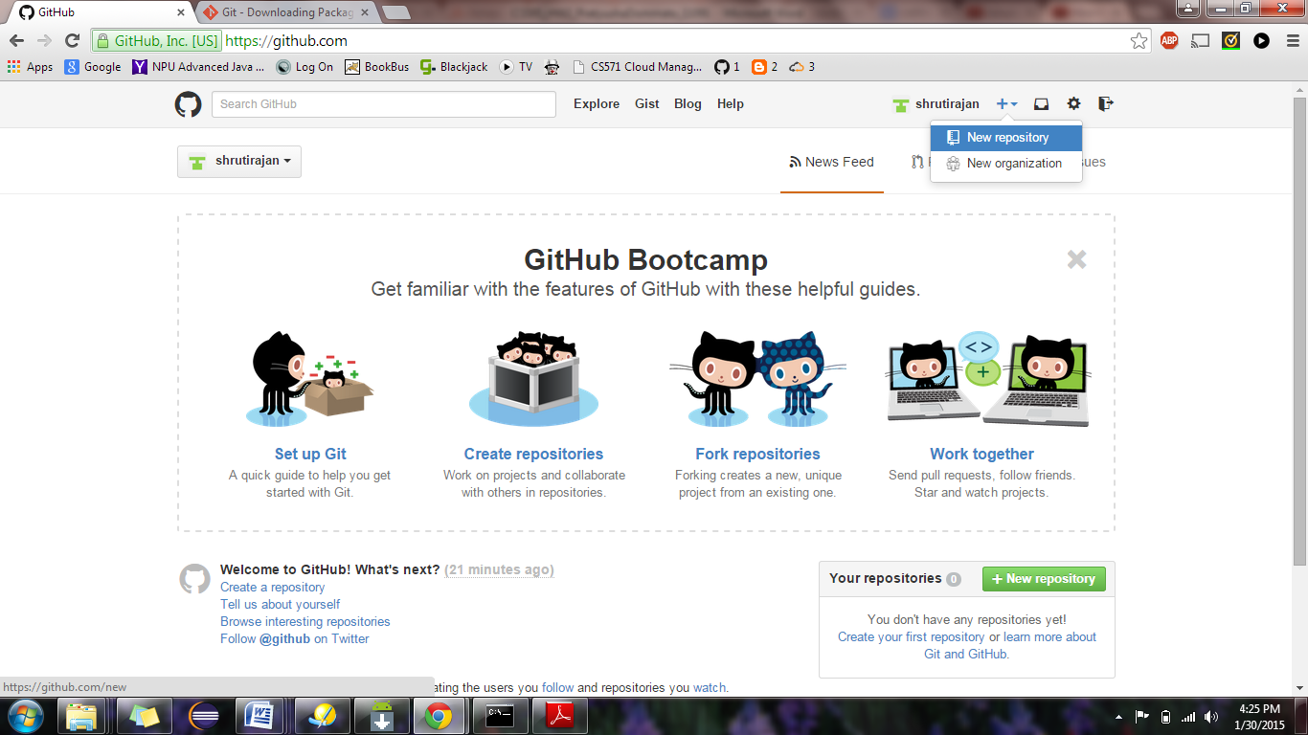

**Type git in Git Bash commandline, it will display list of git commands**

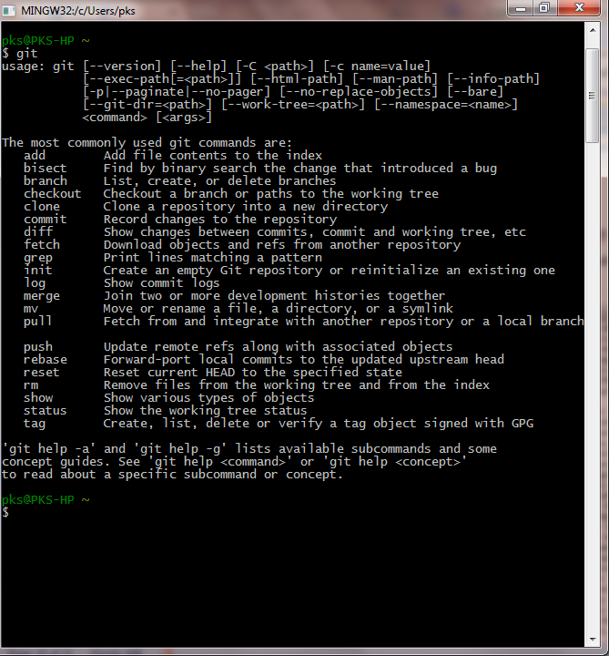

**To add existing project to Git**

click on New repository and type in the repository name

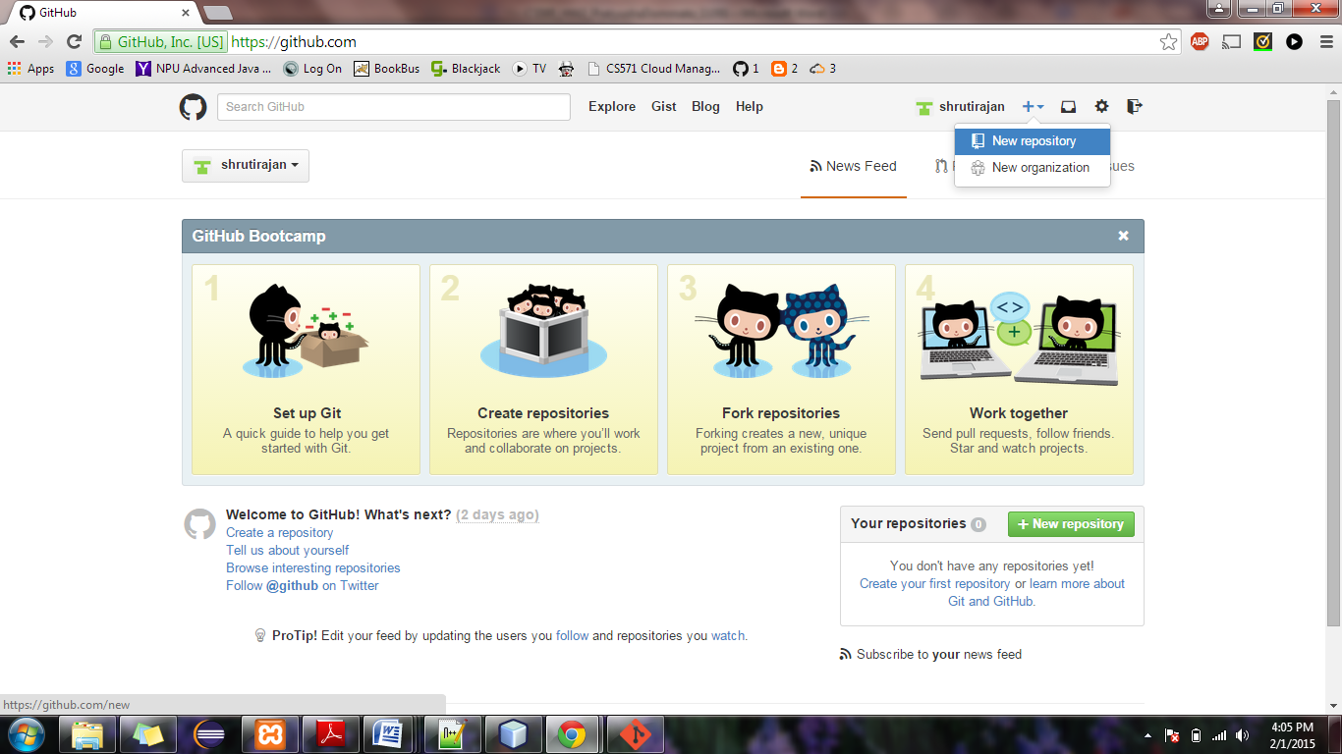

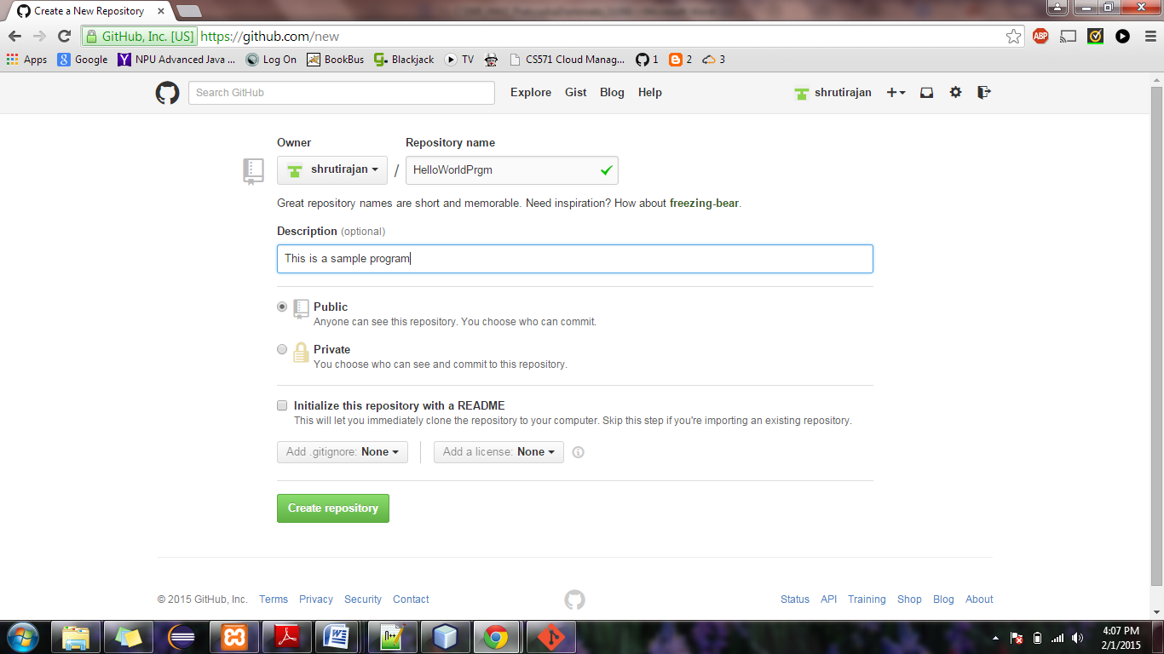

**By clicking on create repository it will display the following page.**

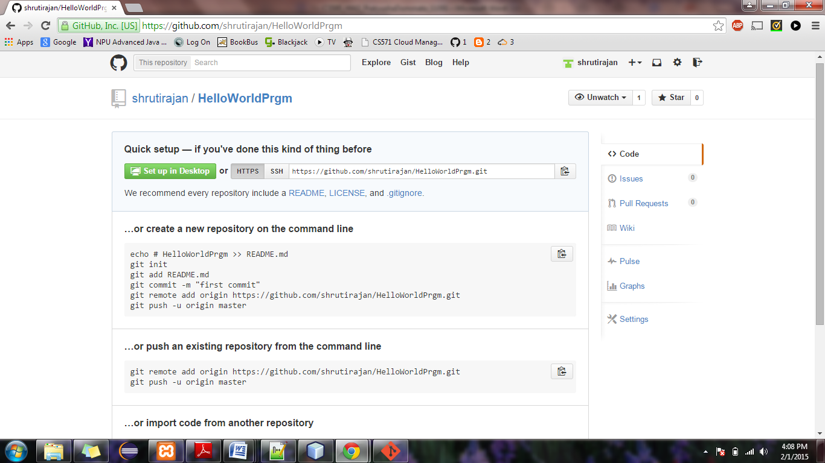

**In Git Bash, change the directory to your project.**

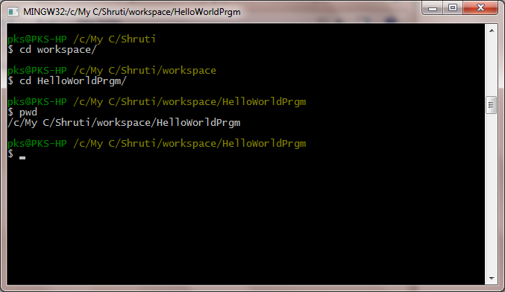

**Initialize the local directory as a Git repository. - $git init**

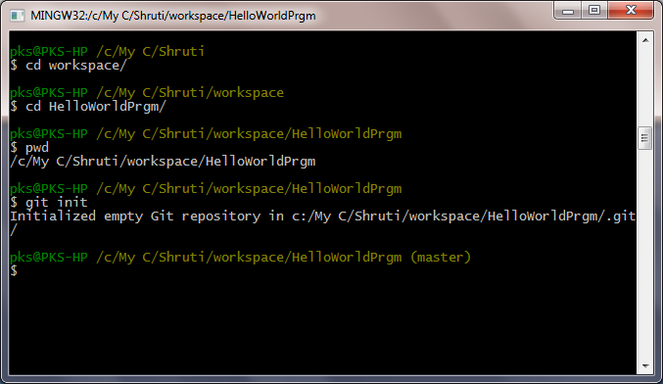

**Add files to repository : $git add .**

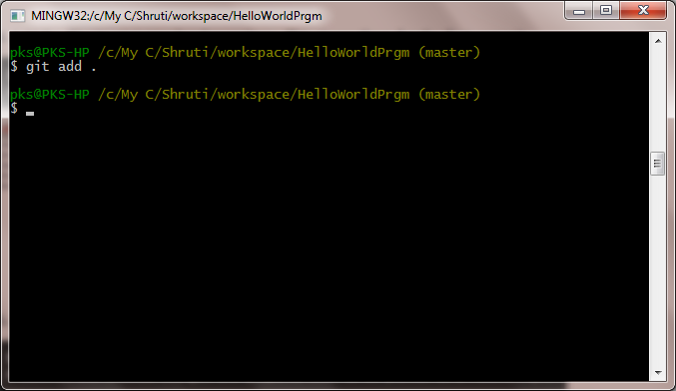

**Commit the files in your repository: $ git commit -m 'First commit'**

**Tell Git your name so your commits will be properly labeled.- $ git config --global user.name "YOUR NAME"**

**Tell Git the *email address* that will be associated with your Git commits. $ git config --global user.email "email ID**"

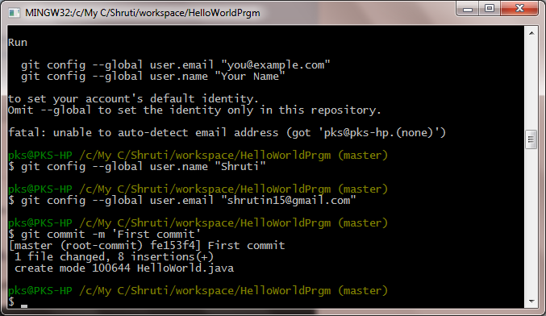

**copy the remote repository URL.**

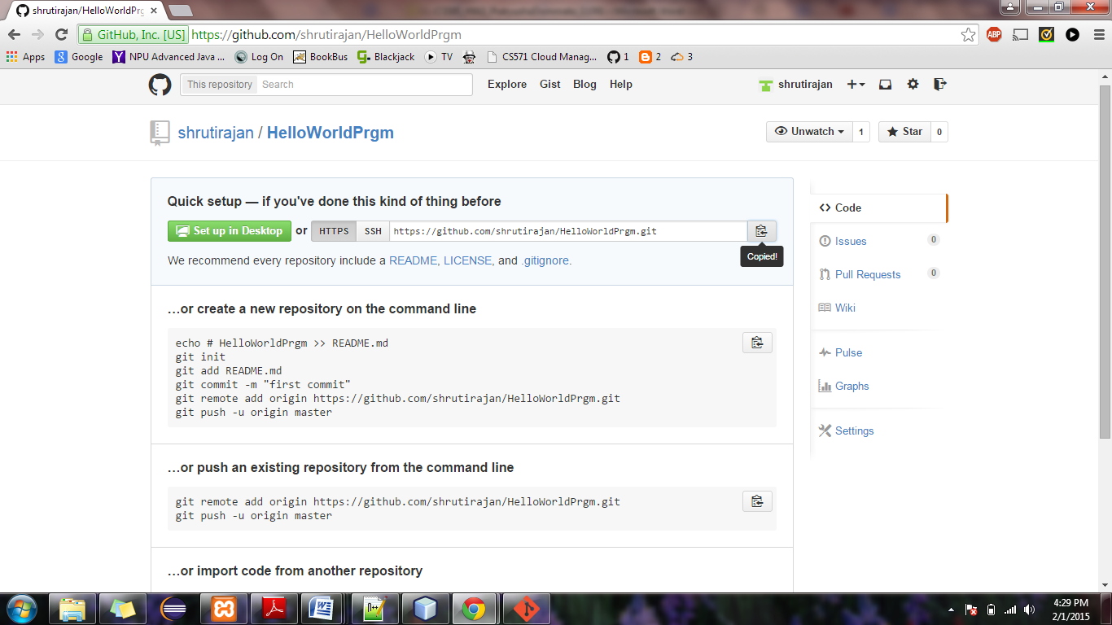

**Paste the URL for the remote repository. $ git remote add origin "remote repository URL"**

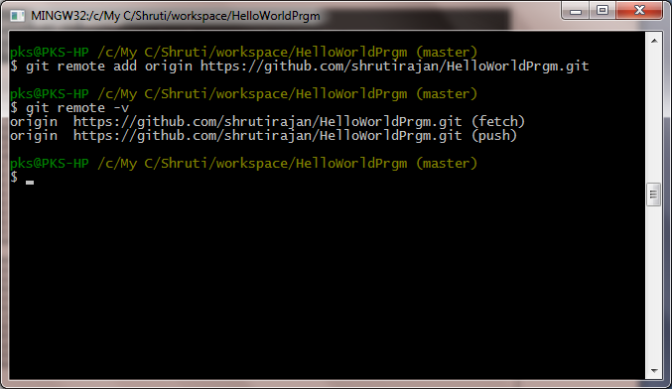

**verify the new remote URL- $ git remote -v**

[**Push the changes**](https://help.github.com/articles/pushing-to-a-remote)**in your local repository to GitHub**. **$ git push origin master**

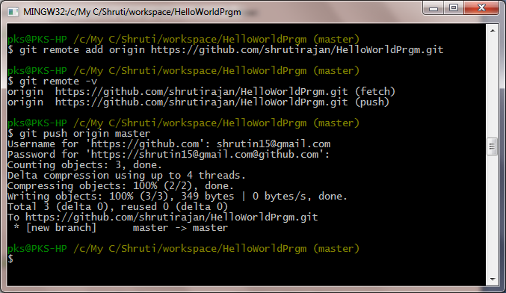

**your project can be now visible in the github account**

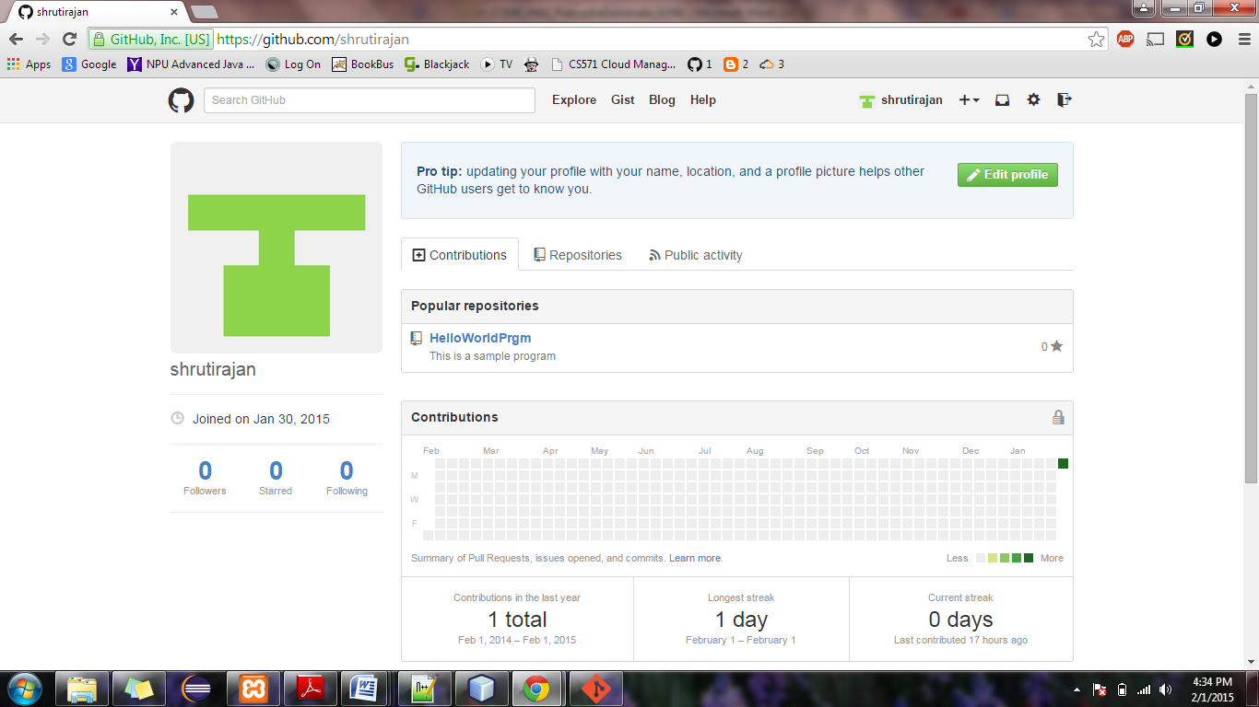

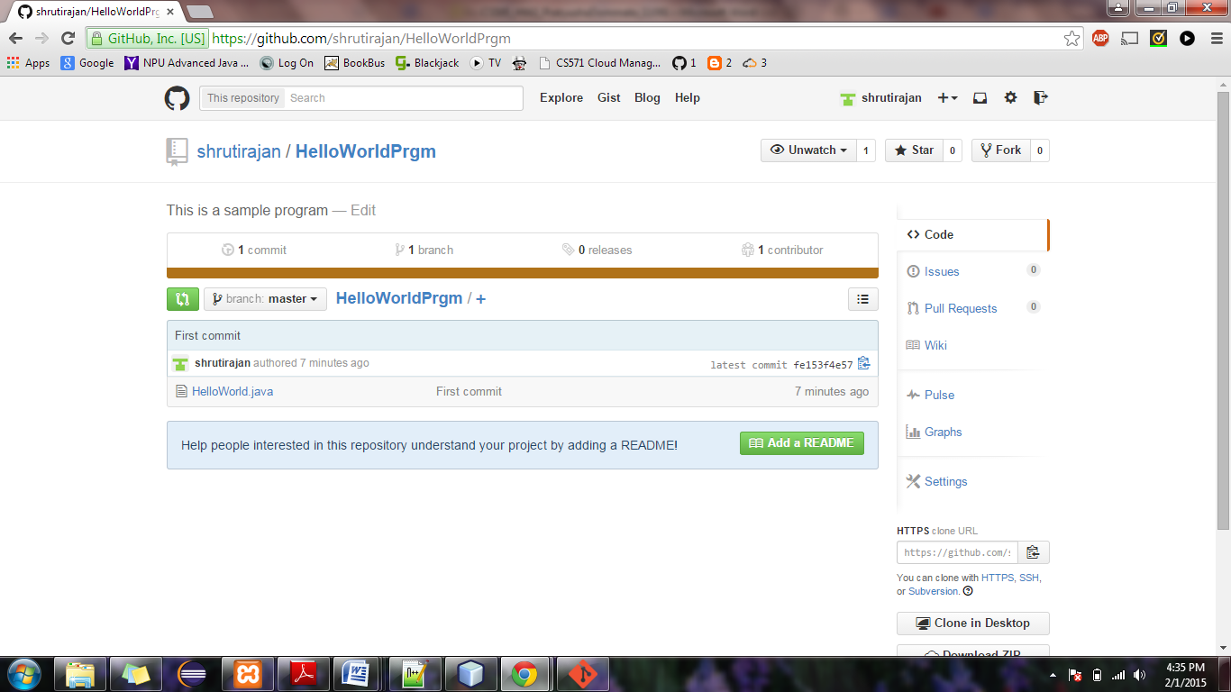

**Cloning repository and then adding a File to repository**

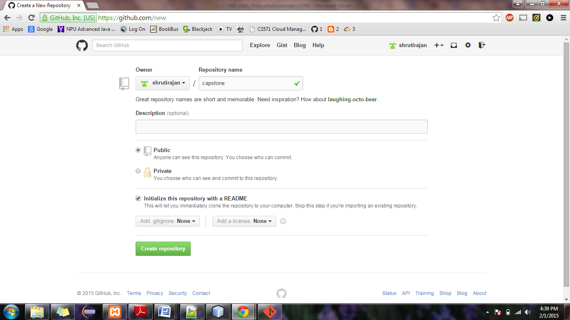

**add a new repository and give a name NOTE : check initialize repository with README option.**

**copy the URL highlighted below**

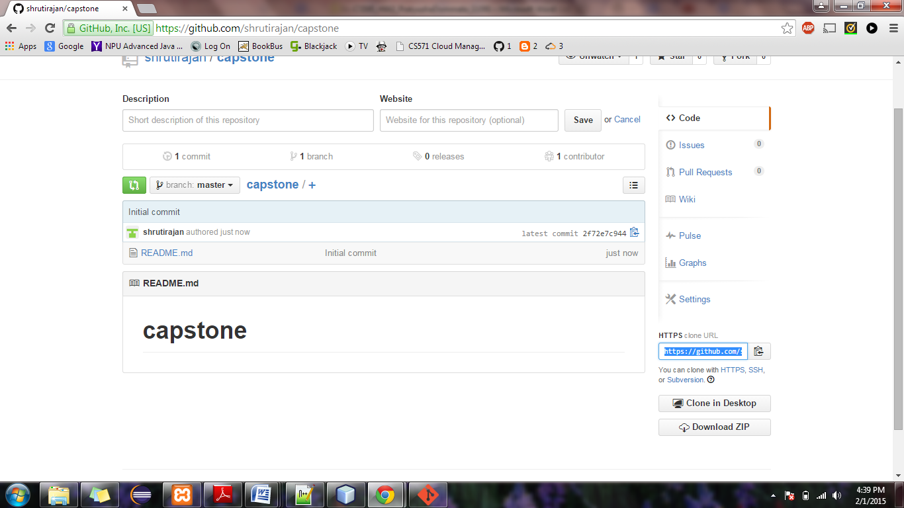

**clone your repository on GitHub**

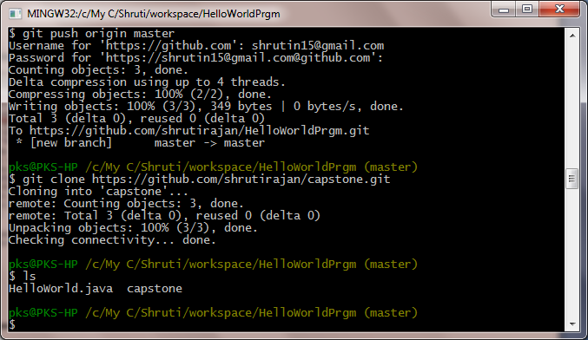

**try making changes to your repository - In this case lets add a test.txt**

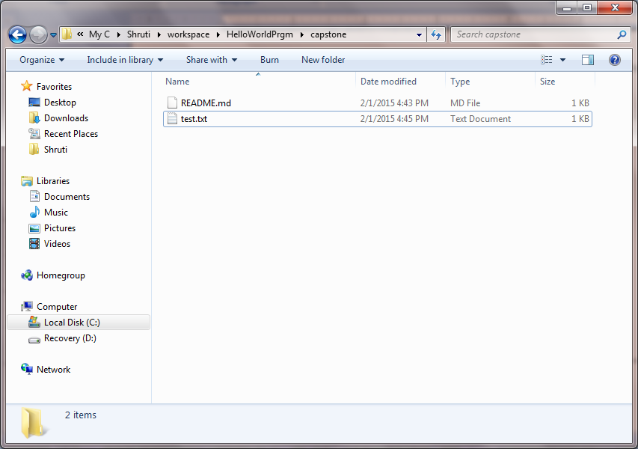

**check status $ git status**

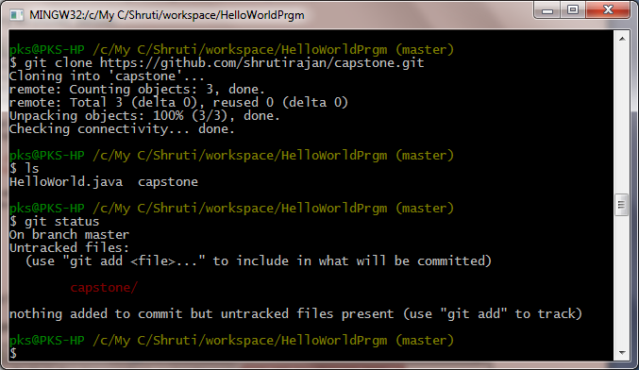

**add & commit to save changes - $ git add test.txt**

**$ git commit -m "message:added .txt file"**

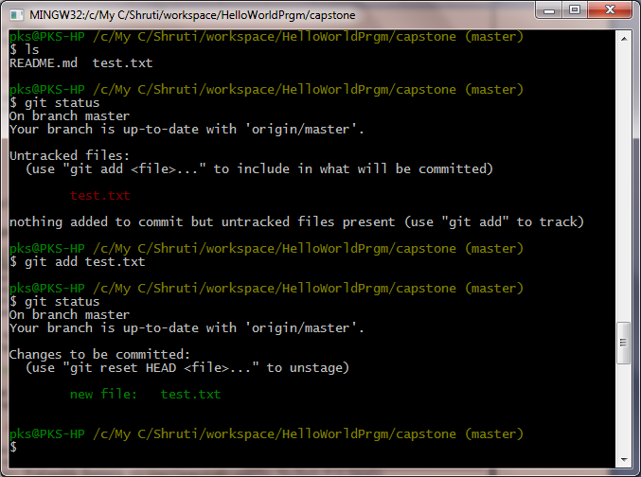

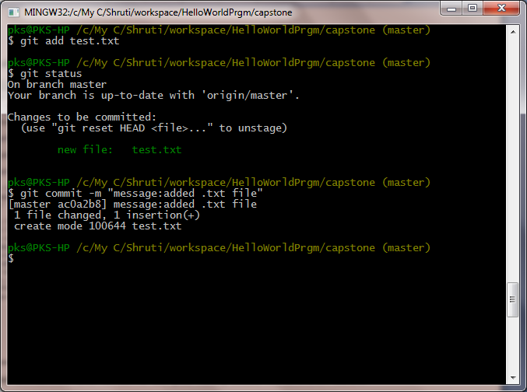

**push the file to your repository - $ git push**

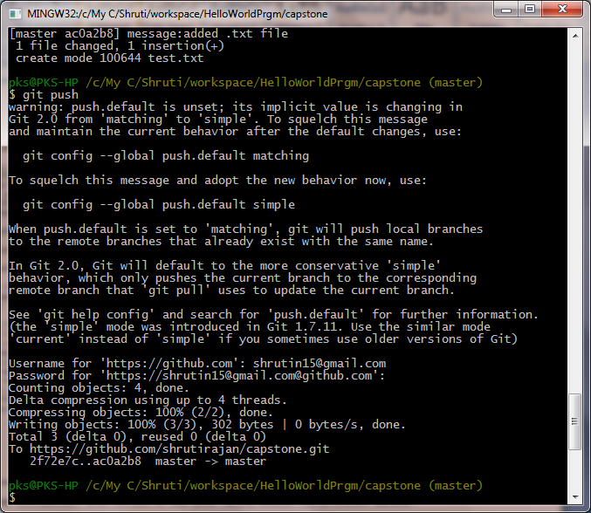

**The changes made is now reflected in your GitHub repository. Refresh to check**

